Thursday

Solve and explain:

A waiter had six tables he was waiting on, with three women and five men at
each table. How many customers total did the waiter have?

Challenge Problem:

On day 12 of the 2002 Winter Olympics, here was the medal count:
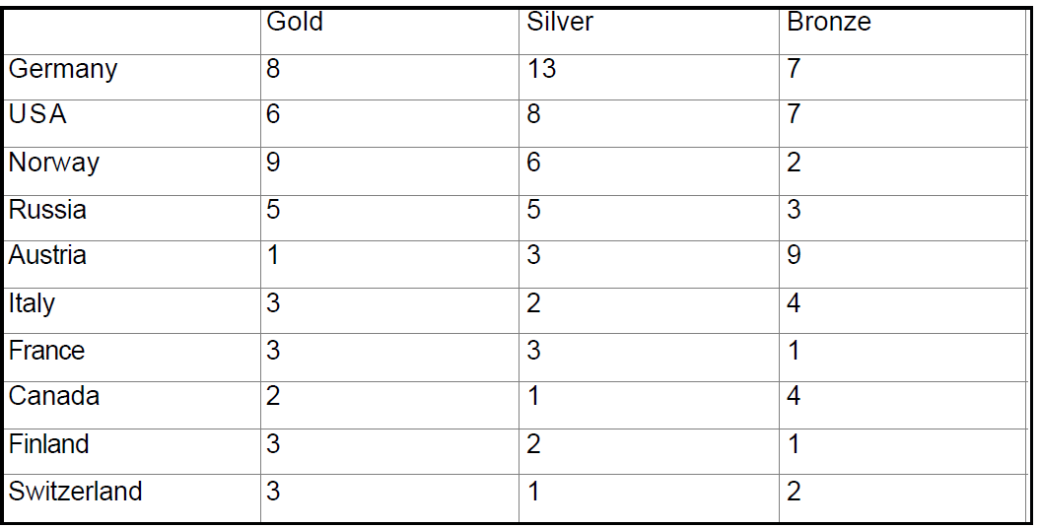

If a bronze medal is valued half as much as a silver medal,
and a silver medal is valued half as much as a gold medal...
Rank the countries above in order of their accomplishment as of day 12 of the Olympic
games.

