How to login to Freckle
Go to Clever

Click on the Freckle app (it looks like a pig)
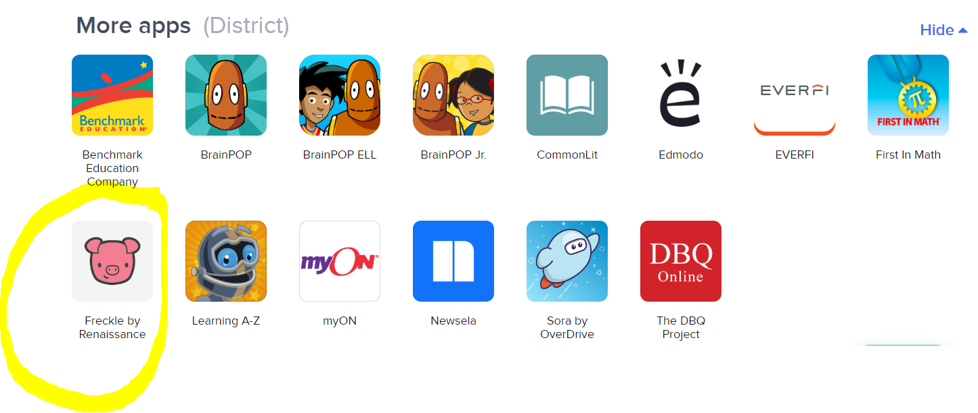

Follow the directions. When prompted, click ELA. You should then see the assignments you need to complete for the week.

