Wednesday – First in Math, Very Important Facts
Login via Clever and click on First in Math
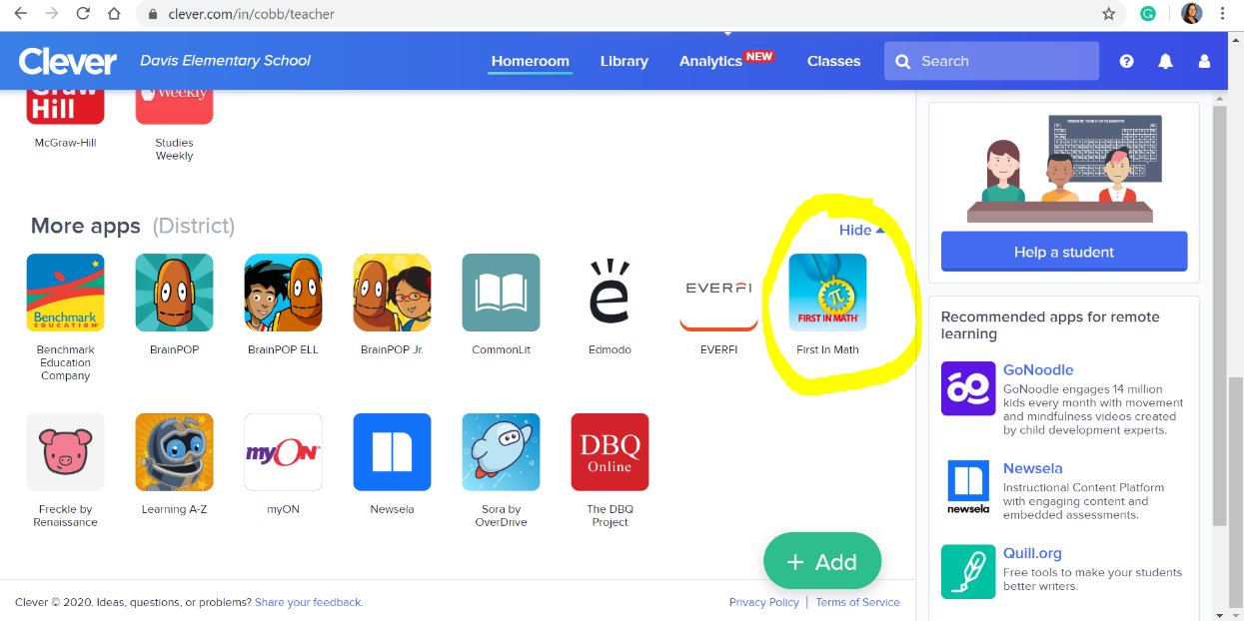
Then click on the “V” for Very Important Facts
Then click on multiplication
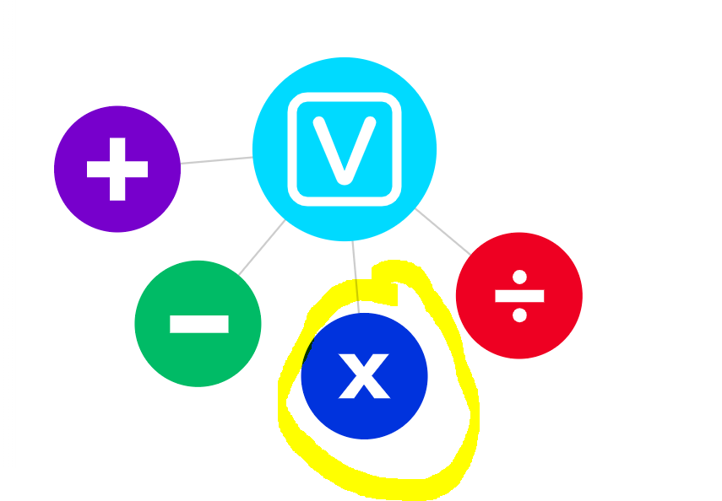
Watch the videos and play the games!

