Where to go for First in Math Tuesday.
- Login using Clever

- Click on the First in Math App 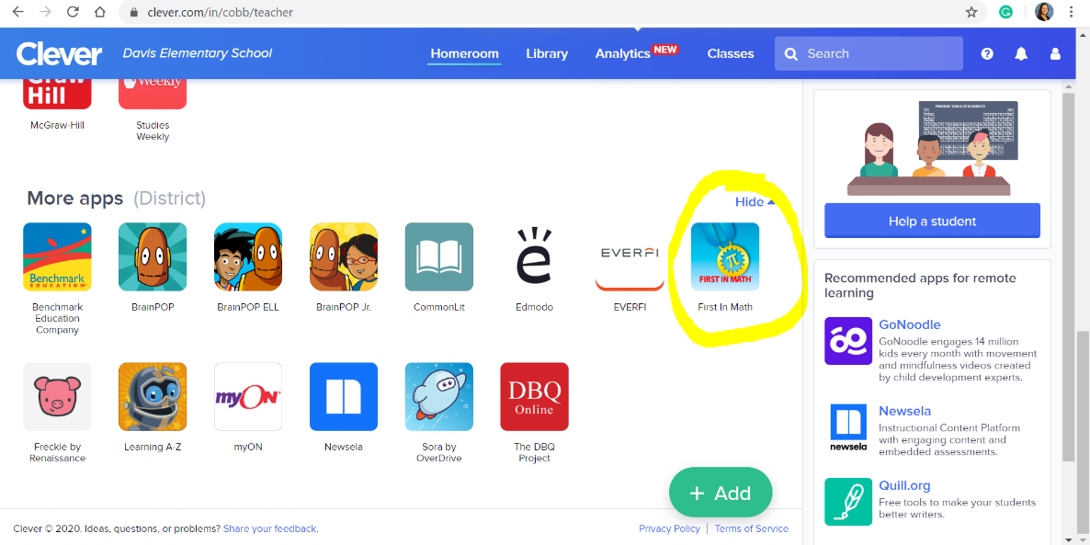

- Click on the top yellow button that says Just the Facts
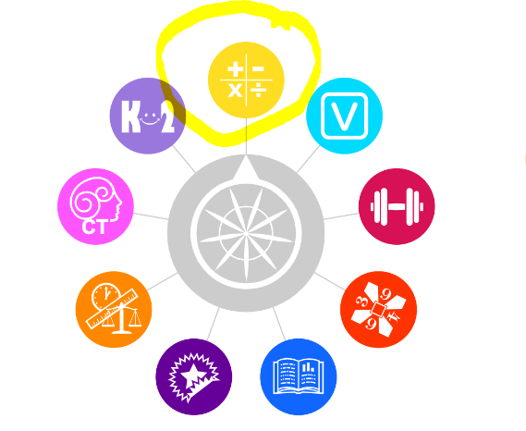
- Click on Whole Numbers
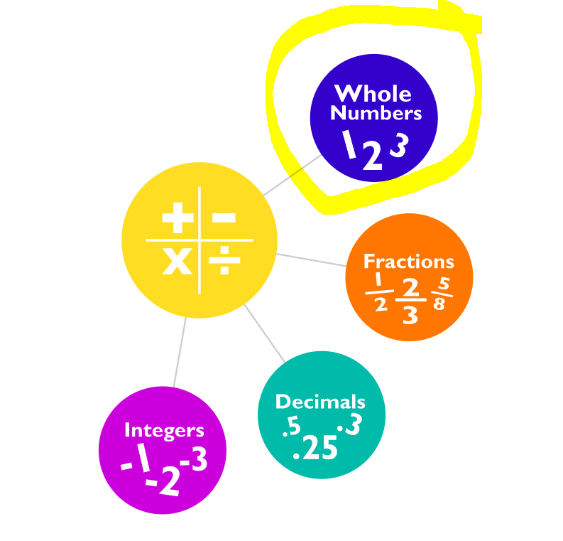
- Click on Division
