Where to go for First in Math Monday.
- Login using Clever

- Click on the First in Math App 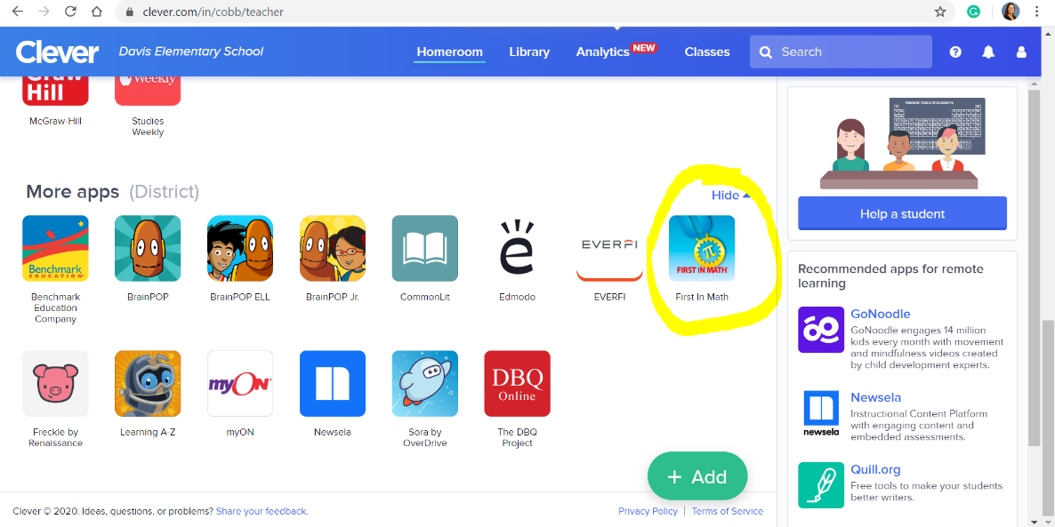

- Click on the top yellow button that says Just the Facts
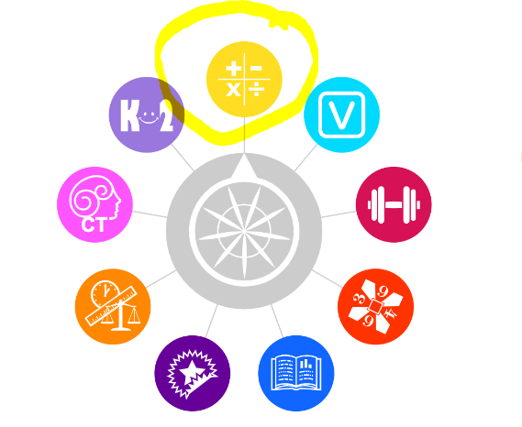
- Click on Whole Numbers
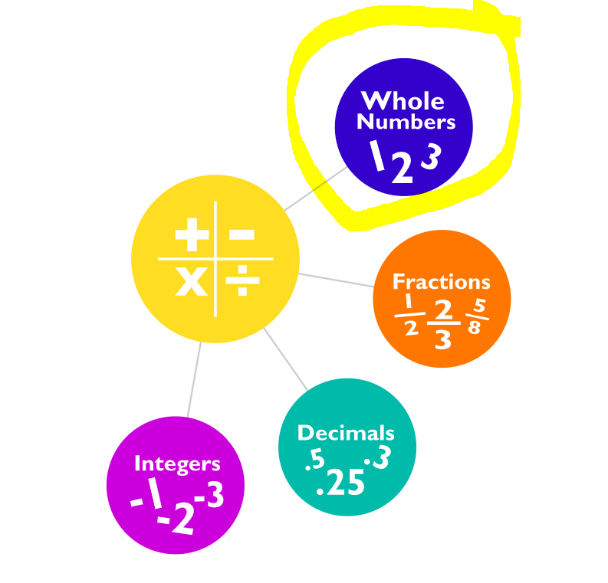
- Click on Multiplication
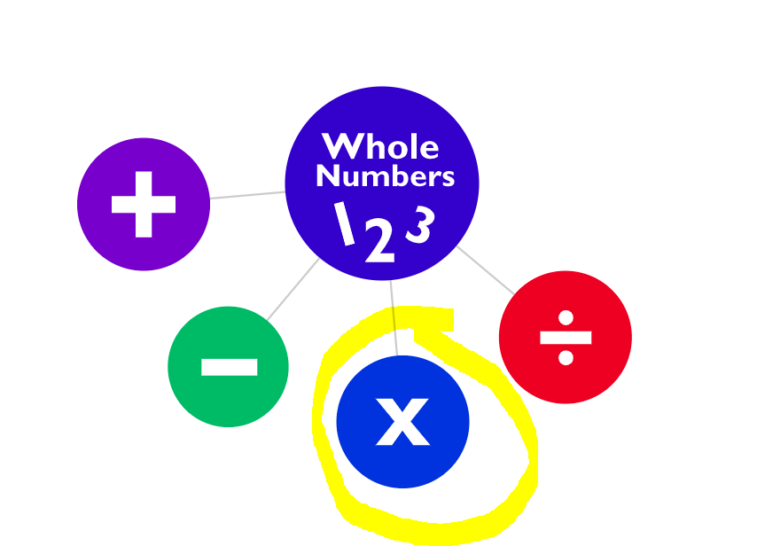

Follow these same directions tomorrow for division!

